Software Requirements Specification

for

LearnSphere

(E-Learning Platform)

Version 1.0

Prepared by

Department of Computer Science and Engineering

Kongu Engineering College

July 2026Software Requirements Specification (SRS) for LearnSphere eLearning Platform

Executive Summary:
This SRS defines the full requirements for LearnSphere, a web-based e-learning platform (using the IEEE 29148/830 standard). It covers two primary user-facing subsystems: (1) the Instructor/Admin portal (back-office for course creation, user management, analytics, etc.) and (2) the Learner portal (front-end for students to browse, enroll, and consume courses). Key functions include user authentication, course and content management, assessments (quizzes/tests), payment processing, progress tracking, and certification. Nonfunctional requirements (performance, security, scalability, etc.) are specified quantitatively. We identify all stakeholders (students, instructors, admins, etc.), glossary terms, and assume the platform will be deployed as a scalable web application (cloud-hosted) with a mobile-responsive UI. Gaps or ambiguities (e.g. unspecified UI frameworks, deployment environment) are noted as Assumptions. Every requirement has a unique ID, priority, rationale, and testable acceptance criteria. A traceability matrix links requirements to verification methods. Diagrams (context, high-level architecture, use cases, sequences, ER model) and tables (requirement catalog, priorities, risks, glossary, traceability) are provided as appendices. Timeline: see Gantt chart (Appendix).
The SRS follows IEEE/ISO standards: an Introduction (purpose, scope, definitions, stakeholders), Overall Description (context, functions, user classes, constraints), and Specific Requirements (external interfaces, detailed functional and non-functional requirements, design constraints, quality attributes). Each requirement is stated as a “shall” clause with measurable criteria and has a unique ID for traceability.

1. Introduction

1.1 Purpose
This SRS specifies all LearnSphere software requirements at the system level. Its purpose is to guide development, testing, and validation, ensuring the platform meets stakeholder needs and regulatory standards. It is intended for project stakeholders, developers, testers, and quality/regulatory auditors. The document enables traceability of each requirement to its origin and acceptance test.

1.2 Scope
LearnSphere is an online learning management system (LMS) enabling instructors to create/publish courses and learners to enroll and complete them. Major features (detailed later) include user management, course/curriculum management, content delivery (videos, texts, quizzes), assessments, certificates, payments, and administrative reporting. The system will be web-based and mobile-responsive, supporting multiple languages (at least English and French). It shall not include features outside a learning platform (e.g. social media beyond course sharing). We assume deployment on cloud infrastructure with internet access. This SRS does not prescribe implementation technologies beyond necessary standards (e.g. payment gateway PCI compliance).

1.3 Definitions, Acronyms, and Abbreviations
- LMS – Learning Management System (the platform).
- Admin – Platform administrator role (manages overall system).
- Instructor – User role that creates courses.
- Learner/Student – User role that consumes courses.
- Module/Lesson – Hierarchical content units in a course.
- UI – User Interface.
- API – Application Programming Interface (RESTful).
- PCI DSS – Payment Card Industry Data Security Standard.
- GDPR – General Data Protection Regulation (EU privacy law).
- FERPA – Family Educational Rights and Privacy Act (US student data law).
(Full glossary in Appendix D.)

1.4 References
- IEEE Std 29148:2018/IEEE 830-1998 (ISO/IEC/IEEE 29148) – “Systems and Software Engineering – Requirements”.
- IEEE Std 829 – Software Test Documentation (for acceptance criteria, traceability).
- FERPA law (US, 34 CFR Part 99).
- GDPR (EU Data Protection Regulation).
- LearnSphere Project Requirements (provided documents, see Assumptions below).

1.5 Stakeholders and Users
- Learners (Students): People seeking to take courses. They browse courses, enroll (free or paid), study content (videos, documents), take quizzes/tests, track progress, and earn certificates. Usability must accommodate varying technical skill levels.
- Instructors: Subject-matter experts who create and manage courses. They design curricula (courses → modules → lessons), upload content (text, images, video, quizzes), and monitor student progress. They need an intuitive back-office UI and reporting features.
- Administrators: Platform operators who manage user accounts, approve content, configure system settings, and oversee financials. They require moderation tools (approve/reject courses, comments), analytics dashboards (user growth, revenue), and ability to generate platform-wide reports.
- System Maintenance Engineers/DevOps: Responsible for deploying, scaling, and securing the system. (Not direct end-users but key for designing nonfunctional requirements.)
- Compliance Officers: Ensure the system meets legal/privacy regulations (FERPA, GDPR, PCI).
(These roles are the primary “actors” in our UML use-case diagrams. Real users may have multiple roles.)

2. Overall Description

2.1 Product Perspective
LearnSphere is a stand-alone web application (cloud-hosted) that functions as a full LMS. It is not part of a larger system; all core services (content, user, payment) reside within its architecture. Figure 1 (below) shows the system context: external interfaces include payment gateways (for processing international transactions with platform commission), email/notification services, and social media APIs (for optional sharing). The front-end is implemented as a responsive web UI; a RESTful API supports possible future mobile apps. All primary data (user profiles, course content, enrollment, etc.) are stored in a backend database (e.g. PostgreSQL or similar) and media files in secure cloud storage (e.g. AWS S3). The system leverages role-based access control.
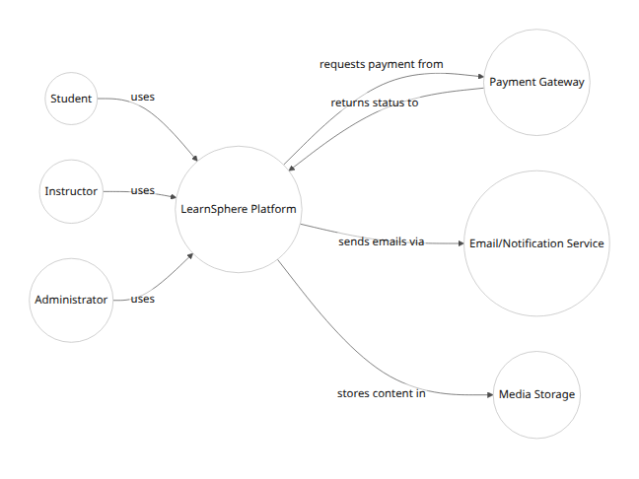
Figure 1. System Context Diagram (Actors and external interfaces).

2.2 Product Functions (Major Features)
Key functions are summarized below (detailed functional requirements in Section 3). These capture the “core” functionality:
- User Account Management: Learners and instructors can register via email or social login (OAuth for Facebook/Google). Accounts have profiles (name, email, bio, avatar, skill level). Role-based access applies (student, instructor, admin). Administrators can filter/search users by various attributes (name, location, courses enrolled).
- Course Catalog and Browsing: Courses are grouped into categories and subcategories. Users can browse or search by category, title, or tags. Courses display detailed info (description, syllabus, instructor, price) and user ratings/reviews.
- Course Creation & Content Management: Instructors (and Admins) create/edit courses via a back-office UI. Each Course comprises hierarchical Parts → Modules → Lessons. Lessons can include text (rich-text editor), images, video, downloadable files (PDF/DOC), and quizzes (MCQ or text). The first lesson/module of each course is marked “free preview” (accessible without payment). Subsequent lessons are locked unless user is enrolled/paid. Video lessons stream via secure player (no download allowed). All uploaded content (videos, documents) is automatically watermarked with the user’s or platform’s identifier to prevent unauthorized copying.
- Enrollment and Payments: Learners can enroll in free courses or purchase paid courses. The system integrates with international payment gateways (e.g. Stripe, PayPal). Payment options presented depend on student’s country. The platform deducts its commission and automatically forwards remaining fee to the instructor. Payment processing must comply with PCI DSS standards. After payment, enrollment is confirmed, and learners gain access to locked lessons. Administrators can also grant course access manually.
- Progress Tracking & Certification: The platform tracks learner progress (completed lessons/modules). Progress is displayed as a percentage for each course. Upon finishing all parts of a course (and passing any required quizzes), a downloadable certificate (PDF with student name, course name, date, instructor name, etc.) is generated. Learners’ dashboards show certificates earned.
- Assessments and Feedback: Instructors can create quizzes/tests in modules. Quizzes can include multiple-choice or written questions. Upon submission, immediate feedback (answers/explanations) is shown. Instructors can also set assignment deadlines. Students can leave ratings and textual reviews per course.
- Social and Community Features: Learners and instructors can share course links on social media. The platform supports basic discussion or Q&A forums under each course (students can ask questions, instructors can answer). Comment moderation is available to admins/instructors.
- Notifications: Email notifications are sent for key events: registration confirmation, password reset, course enrollment, new course publication, assignment deadlines, certificate earned, etc. The user can opt in/out of notifications.
- Administration and Analytics: Admins can approve or reject newly created courses before they go live. An admin dashboard provides analytics (number of users, enrollments per course, revenue reports, course popularity, system usage). Admins can manage site-wide settings (e.g. commission rate, default certificate template, site banners).
- Search and Navigation: Full-text search across courses, tags, and instructors. Filters for language, category, price, level (beginner/advanced). Mobile-responsive navigation UI.
- Localization: The UI supports at least English and French (initial languages); all text is externalized for easy translation.
These features align with typical LMS capabilities, augmented by content protection (non-downloadable, watermark) and social sharing.

2.3 User Classes and Characteristics
- Guest/Visitor: Unauthenticated user who can browse free courses and view some content. (Must register to access more.)
- Student/Learner: Has basic computer literacy; uses platform via web browser or mobile. Needs clear navigation and help.
- Instructor: Typically tech-savvy; uses course creation tools (rich editors, uploads). Expects intuitive authoring interface and dashboards.
- Administrator: Power-user with deep knowledge. Manages users and content. Requires efficient data filtering and system analytics.
For all users, we assume standard web accessibility (WCAG 2.1) compliance for usability. The interface should be intuitive and consistent (e.g. similar to other e-learning sites) to minimize training.

2.4 Operating Environment
- Hardware: The application will run on web servers in a cloud environment (e.g. AWS/GCP/Azure) with horizontal scalability. End-users access via modern web browsers on desktops, tablets, or phones. No special hardware required on user side.
- Software: The back-end will run on a web application framework (suggested: Django/Python or Node.js) on Linux servers. Data will be stored in a relational database (e.g. PostgreSQL) with media in object storage (e.g. S3). The front-end will be HTML5/CSS3/JS and mobile-responsive (or a single-page app framework). Standard HTTPS/TLS for secure transport.
- Network: Continuous Internet access with sufficient bandwidth to stream video. We assume low latency (<200ms) for key user interactions.
- Integration: Interfaces to third-party services: Payment Gateway APIs (REST), OAuth for social login, Email/SMS provider APIs. We assume these services are available and have documented APIs.

2.5 Design & Implementation Constraints
- Standards: All payment processing must meet PCI-DSS compliance. Personal data handling must comply with GDPR (if EU users) and FERPA (if U.S. student data). All communications must use TLS 1.3. Videos streamed must use HTML5-compatible DRM to prevent downloads.
- Technology Stack: (If specified) Use of open-source web frameworks (e.g. Django or React) is allowed. We assume the system will run on cloud VMs or containers; compliance with possible institutional IT policies may apply.
- Scalability: The system design shall allow horizontal scaling of web servers and database read replicas to support an increasing number of concurrent users (assume up to 5,000 concurrent users at launch).
- API Design: RESTful APIs should follow best practices (stateless, versioned).
- Legal: Must support audit logs (see Security requirements) and data export to comply with data access rights.

2.6 Assumptions and Dependencies
- We assume LearnSphere is for adult learners or higher education (if K-12, COPPA compliance may be needed; treat as out-of-scope unless specified).
- Payment providers (Stripe, PayPal) are available in target countries.
- Users have reliable Internet; offline mode is not required.
- Video content encoding uses common formats (MP4/H.264).
- The platform does not require integration with legacy systems (unless specified); it is standalone.
- No third-party LMS import/export is required (unless added).
- We assume initially moderate user base; hardware sizing decisions are deferred but outlined in (not included here) design documents.
(Any further unstated assumptions should be reviewed before implementation.)

3. Specific Requirements

3.1 External Interface Requirements
3.1.1 User Interface: The web UI shall be responsive and mobile-friendly (usable on desktops, tablets, phones). It shall support English and French languages (text, labels, messages). All text shall be externalized for translation. UI pages (e.g. course page, dashboard) shall load within 3 seconds under typical load. Forms (registration, login, profile) shall validate input client-side (with appropriate messages) and server-side. (Detailed UI mockups/specs would be in separate UI design docs.)
3.1.2 Communication Interface (APIs): The system shall provide a RESTful JSON API for all core operations (user CRUD, course/content CRUD, enrollment, etc.) for potential mobile clients. API endpoints shall require authentication tokens (OAuth2/JWT). The API shall handle 100 requests/sec baseline. Interfaces to external services (payment, email, social login) use HTTPS with JSON/XML payloads. All external calls must handle timeouts and errors gracefully (retry or failover).
3.1.3 Hardware Interfaces: Not applicable to end-users. On server-side, no specialized hardware integration is required (e.g. biometric scanners).
3.1.4 Software Interfaces: The platform shall integrate with at least one external payment gateway (e.g. Stripe or PayPal API, adhering to their developer guidelines). It shall optionally integrate OAuth providers (Facebook, Google) for social login. The system may integrate with an email delivery service (e.g. SendGrid) via SMTP/REST API. Interfaces shall be documented in an Interface Control Document (ICD).
3.1.5 Communication Protocols: Web traffic shall use HTTPS/TLS. Real-time features (e.g. live Q&A chat) if any shall use WebSocket or WebRTC with secure channels.

3.2 Functional Requirements
Each functional requirement (FR) is given an ID, statement, priority, and acceptance criterion.

3.2.1 User Account and Authentication
- FR-UC-001 (High): The system shall allow new users to register as Learner or Instructor, using email/password or OAuth (Facebook/Google).
- Rationale: Enables access control by role.
- Acceptance: A new user can sign up and, if email login, receives a confirmation email and activates the account. Social login creates an account with profile info.
- FR-UC-002 (High): The system shall enforce role-based access: Learners cannot access instructor/admin functions, and only Admin users can access the admin panel.
- Acceptance: When logged in as learner, instructor-only features (e.g. create course) are hidden/disabled.
- FR-UC-003 (Medium): Users shall be able to reset forgotten passwords via email link.
- Acceptance: Entering an email sends a reset link; password reset updates the account.
- FR-UC-004 (Low): The system shall allow users to update their profile (name, bio, photo, password).
- Acceptance: User edits profile fields and changes are saved.

3.2.2 Course & Content Management
- FR-CM-001 (High): An Instructor shall be able to create a new Course, specifying title, description, category, language, price (free or paid), and other metadata.
- Acceptance: New course appears in admin queue (if approval required) or immediately in catalog (if auto-approved) with given details.
- FR-CM-002 (High): Each Course shall allow multiple Parts, each Part may contain multiple Modules, and each Module may have multiple Lessons.
- Acceptance: Instructor can add hierarchical Parts→Modules→Lessons via the UI. The structure is saved and visible.
- FR-CM-003 (High): Lessons shall contain rich content: text (rich-text), images, embedded videos, documents (PDF/DOC), and quiz questions. The UI shall provide editors/uploaders for each type.
- Acceptance: Instructor uploads text and media to a lesson; learners see them correctly. Videos stream, documents download (with watermark if applied).
- FR-CM-004 (High): The first Module of each course shall be marked free for all users; access to subsequent Modules shall require login (and payment if the course is paid).
- Acceptance: A visitor can preview Module 1 without login. Trying to access Module 2 prompts login and/or purchase.
- FR-CM-005 (High): When uploading video or documents, the system shall automatically apply a semi-transparent watermark (e.g. with site name or user ID).
- Acceptance: Downloaded/viewed content has visible watermark; watermark code cannot be easily removed.
- FR-CM-006 (High): The system shall prevent video downloads. The video player must disable right-click download and block direct file links.
- Acceptance: Learners cannot download video files through the UI or source links.
- FR-CM-007 (Medium): Instructor can organize course content by drag-and-drop ordering of modules/lessons.
- Acceptance: Order changes in UI reflect in learner view immediately.

3.2.3 Enrollment and Payments
- FR-EP-001 (High): Learners shall be able to enroll in free courses without payment by clicking “Enroll” (with login/registration).
- Acceptance: The learner’s dashboard shows the course as “Enrolled”.
- FR-EP-002 (High): For paid courses, the system shall integrate with a payment gateway and charge the learner. The platform commission shall be automatically deducted, and the remainder disbursed to the instructor.
- Acceptance: A learner enters payment info and completes a purchase. Payment transaction is recorded; course shows as “Purchased”.
- FR-EP-003 (High): The system shall display payment options based on user’s country (currency, available methods).
- Acceptance: Changing profile country or IP address shows local currency and appropriate gateway.
- FR-EP-004 (High): The system shall comply with PCI-DSS for all payment data. No credit card info is stored after transaction (only tokens/confirmations).
- Acceptance: A third-party PCI audit can verify no raw card data is in the database.
- FR-EP-005 (Medium): A learner shall see their transaction and enrollment history in their profile (date, course, amount).
- Acceptance: Learner opens profile and views a list of past course purchases with dates and amounts.

3.2.4 Learning Activities
- FR-LA-001 (High): The platform shall track each learner’s progress (% of course completed) and display it on the course and dashboard pages.
- Acceptance: After a learner finishes a lesson, the progress bar (or percentage) increases accordingly.
- FR-LA-002 (High): The system shall generate a printable/downloadable certificate (PDF) upon course completion, including learner’s name, course name, date, instructor name, and platform signature.
- Acceptance: A learner who completed all modules clicks “Get Certificate” and receives a PDF with correct data.
- FR-LA-003 (Medium): Learners shall be able to bookmark/favorite courses to view later.
- Acceptance: Clicking a “favorite” icon adds the course to a “My Favorites” list.

3.2.5 Assessments and Feedback
- FR-AF-001 (High): Instructors shall be able to create quizzes at the end of modules, consisting of MCQs or short-answer questions. Correct answers and explanations can be stored.
- Acceptance: Instructor creates a quiz with questions and answers. The quiz appears to learners after module completion.
- FR-AF-002 (High): When a learner submits a quiz, the system shall immediately display score and, for MCQs, indicate correct answers and explanations.
- Acceptance: After submission, the UI shows “3/5 correct” and highlights right/wrong with comments.
- FR-AF-003 (Medium): Learners shall be able to rate courses (1–5 stars) and write text reviews. Instructors/Admin shall moderate reviews.
- Acceptance: A learner submits a review; it is visible on the course page (or flagged for moderation if containing banned words).

3.2.6 Social and Community Features
- FR-SC-001 (Low): The system shall allow sharing a course link on Facebook, Twitter, and LinkedIn.
- Acceptance: Clicking a share button opens the respective social network share dialog with course link.
- FR-SC-002 (Low): A discussion forum (or comment thread) shall exist under each course for Q&A between learners and instructors.
- Acceptance: A learner posts a question; the instructor/admin can reply.

3.2.7 Administrative Features
- FR-AD-001 (High): Admin shall review and approve new courses and instructor accounts before they become public.
- Acceptance: New course submissions appear in an “Admin Queue” view; Admin can approve (course goes live) or reject (with feedback).
- FR-AD-002 (High): Admin shall be able to filter/search all users by name, email, role, country, courses purchased, and registration date.
- Acceptance: Admin enters filter criteria and sees the matching user list.
- FR-AD-003 (Medium): The Admin dashboard shall display analytics: number of users (by role), courses published, monthly revenue, and top courses by enrollment.
- Acceptance: Dashboard metrics correctly update (e.g. on date change).
- FR-AD-004 (Low): Admin shall configure global settings: platform commission %, site contact info, default certificate template.
- Acceptance: Changing a setting takes effect (e.g. new commission rate applies to subsequent sales).
(All functional requirements have traceability IDs and acceptance tests in the full catalog – see Appendix A.)

3.3 External Interface Requirements (Detail)
User Interface (UI): The UI shall use a consistent navigation with clear menus (e.g. “My Courses”, “Profile”, “Administration”). All forms shall sanitize inputs to prevent injection attacks. Error messages shall be friendly but not expose system internals. The UI shall conform to accessibility guidelines (alt text on images, high contrast).
Payment API: The system shall log all payment transactions with sufficient detail (user ID, course ID, transaction ID, timestamp, status). Refunds shall be possible via admin interface (triggering the payment gateway’s refund API).
Notification Service: Emails (e.g. welcome, receipts) shall be sent via an external SMTP or email API. Template-based messaging shall be supported (e.g. using templates for different notification types).
Mobile App/API: While mobile apps are future scope, our API shall be fully functional and tested, enabling future native or hybrid mobile applications.

3.4 Nonfunctional Requirements
Every nonfunctional requirement below is quantitative where applicabl.
Performance: Under normal load (1000 concurrent learners), the platform shall render any course page within 3 seconds. The system shall support up to 5,000 concurrent users with linear scaling. Batch processes (e.g. reporting) shall complete within 1 hour for a dataset of 100,000 users.
- Security: All user passwords shall be stored hashed (bcrypt or better). The system shall enforce HTTPS for all traffic. Role-based access control shall prevent unauthorized actions (e.g. students accessing admin pages). Regular penetration testing shall be performed before release. Sensitive data shall be encrypted at rest and in transit. Audit logs shall record all admin actions (user/course changes) with timestamp and actor. Authentication shall support optional multi-factor (MFA) for instructor/admin roles. The platform shall automatically lock accounts after 5 failed login attempts for 30 minutes.
- Availability & Reliability: The system shall have 99.5% uptime (“five nines” minus scheduled maintenance). Backups of the database and media shall occur nightly with weekly offsite retention. In case of failure, the system shall automatically switch to a standby server within 5 minutes (high-availability failover).
- Maintainability: The codebase shall be modular (e.g. MVC pattern) with clear documentation. All APIs and database schema changes shall be version-controlled. Bug fixes and new features shall be implementable with minimal code duplication.
- Scalability: The architecture shall support horizontal scaling (stateless app servers, load balancer). Database shall support read replicas for load. The system shall allow adding more servers without downtime.
- Usability: Usability tests shall show ≥90% task success for student/instructor workflows (e.g. enrollment, course creation). The interface shall have consistent styling and tooltips/help text. All content pages shall follow a consistent layout with logical progression.
- Localization: The system shall support at least English and French (Locale EN/FR). All UI text, date formats, and number formats shall adapt based on user preference.
- Compatibility: The web UI shall function on the latest two versions of Chrome, Firefox, Safari, and Edge. The system shall be responsive on devices down to 320px width (smartphone screen).
- Backup/Recovery: Backups shall occur daily. A full system restore shall be testable quarterly, with Recovery Time Objective (RTO) of 4 hours and Recovery Point Objective (RPO) of 24 hours.
- Privacy: Personal data usage shall comply with GDPR principles (data minimization, purpose limitation). Users shall be able to request deletion of their account and data (“right to be forgotten”). This includes all personal fields and tracing of activities.
- Data Integrity: The system shall ensure referential integrity in the database (e.g. no orphaned enrollment records). All form submissions shall be validated.
- Regulatory Compliance: The platform shall implement controls for FERPA: only authorized users (the student, instructors of their courses, and admins) can view a student’s records. Reports for audits (e.g. access logs) shall be producible on demand.
Each NFR has associated acceptance tests (e.g. performance tests, security audits). The system’s design will prioritize verifiability and testability; e.g. performance targets must be demonstrable via load testing.

3.5 Design Constraints
- Technology: The requirement “Front-End and Back-End using Django” was given. If selected, the system must use the Django framework (Python) for the server side, with a JavaScript framework (e.g. React) for the front end.
- Third-Party Services: Must use specified payment and email providers (or approved alternatives). Any change requires regression testing.
- Hardware/Platform: If clients require specific hardware (e.g. school labs), then app must still function on minimal spec devices (Pentium-class CPU, 2GB RAM, modern browser).
- Regulatory: Must obtain SSL certificates from a trusted CA; if hosted in EU, data must reside on EU servers.

3.6 Quality Attributes
Following IEEE 830 quality criteria, the SRS itself (and by extension, our requirements) must be:
- Verifiable: Each requirement can be checked by tests or inspections.
- Unambiguous: Statements have a single interpretation; ambiguous words like “fast” are avoided. (We use concrete metrics where possible).
- Complete: All significant cases, including error conditions (e.g. failed payment) are addressed. We document responses to invalid inputs (e.g. incomplete form).
- Consistent: No two requirements conflict (e.g. one doesn’t say “must log in” and another says “guest can view”). Cross-checks have been done to ensure consistency.
- Traceable: Every requirement is linked to its origin and to a test case. (See Appendix B.)
- Modifiable: Requirements are grouped logically (by function) and numbered so changes can be made easily. We maintain a glossary to avoid ambiguity.

3.7 Safety and Privacy Requirements
- Content Security: To protect intellectual property, video lessons shall not be downloadable. All media shall carry a visible watermark.
- Data Privacy: Sensitive student info (grades, personal data) shall only be accessible to authorized roles (instructor of the course, the student themselves, and admin) – aligning with FERPA. The system shall delete or anonymize a user’s data upon account deletion request (per GDPR).
- Incident Response: In the event of a data breach, the system shall log the incident, lock affected accounts, and notify affected users and authorities within 72 hours (as per GDPR breach notification rules).
- Content Standards: Instructors shall not be allowed to upload banned materials (e.g. copyrighted images without license). A moderation process for DMCA takedown requests shall be established.

3.8 Legal and Compliance
- FERPA: The system shall provide students the ability to view and amend their educational records (e.g. profile, grades) as per FERPA requirements.
- GDPR: For EU users, explicit consent shall be obtained on registration. Users shall be able to export their personal data. All stored personal data shall be protected according to GDPR data protection rules.
- PCI DSS: As above, payment card handling must meet PCI standards.
- Accessibility (ADA/WCAG): The UI shall meet WCAG 2.1 Level AA guidelines for accessibility (for example, screen-reader compatibility, keyboard navigation).
- Intellectual Property: Instructors retain content ownership, but LearnSphere shall have rights to display and distribute content per the platform’s Terms of Service.

3.9 Traceability and Acceptance Criteria
Each requirement in Sections 3.2–3.8 has a testable acceptance criterion (see examples above). A Traceability Matrix (Appendix B) maps each FR/NFR ID to its verification method (e.g. exam, demo, test) and to design/test artifacts. For instance, FR-CM-001 (“create course”) is linked to the “CreateCourse” component and to test case TC-FR-CM-001. Backward traceability ensures each requirement stems from stakeholder needs, and forward traceability ties it to implementation and tests. Every requirement will end in “shall” and include measurable thresholds or outputs to satisfy verifiability.

4. Appendices

Appendix A: Requirements Catalog (Summary)
ID | Priority | Requirement (abridged) | Source/Rationale | Acceptance Criteria
FR-UC-001 | High | User Registration: Users shall register (email/pass or OAuth). | User need to login; aligns with [3] | New user signs up; receives confirmation; can log in.
FR-CM-001 | High | Course Creation: Instructors shall create courses with meta. | Core LMS function | Instructor creates course; course appears in system (pending approval).
FR-CM-004 | High | Free Preview: 1st module free; others locked (login/payment). | Encourage sign-up | Visitor sees module 1 accessible; module 2 requires login/payment.
FR-EP-002 | High | Payment Integration: Platform shall process payments, auto-split commission. | Monetization | Learner pays and is enrolled; instructor gets funds (after fee).
FR-LA-002 | High | Certificate: Generate PDF certificate on course completion. | Completion incentive | On final quiz pass, student can download PDF certificate with correct data.
NFR-PERF | High | Performance: <3s page load @ 5K users. | Usability standard | Load test shows average <3s response under target load.
NFR-SEC | High | Security: Encrypt all sensitive data; comply GDPR/FERPA. | Privacy laws | Demo of SSL, encrypted DB; privacy audit; GDPR consent prompt works.
NFR-USAB | Medium | Usability: UI must be intuitive (WCAG 2.1 AA). | Accessibility law | Usability test ≥90% task success; no major WCAG violations.
… | … | … | … | …
Table A.1: Sample of the requirements catalog (full list in master doc). Each requirement includes an ID, priority, source (stakeholder need or standard), and acceptance criteria.

Appendix B: Traceability Matrix (Example)
Req ID | Originating Need | Design Module/Doc | Test Case ID
FR-UC-001 | Stakeholder User Story | AuthService | TC-UC-001
FR-CM-004 | Business Rule | CourseService | TC-CM-004
FR-EP-002 | Stakeholder Spec. | PaymentService | TC-EP-002
FR-LA-002 | Instructor Use Case | CertificateModule | TC-LA-002
NFR-PERF | SLA Requirement | Performance Testing | TC-NFR-PERF
... | ... | ... | ...
Table B.1: Example of requirements traceability (full matrix attaches each requirement to its source, relevant design element, and test case).

Appendix C: Risk Assessment
Risk ID | Risk Description | Likelihood | Impact | Mitigation
R1 | Data breach of personal/student information. | Medium | High | Encrypt data at rest/in transit; regular security audits; enforce strong auth (MFA).
R2 | Payment processing failure or fraud. | Low | High | Use trusted payment gateway; adhere to PCI DSS; refund process established; transaction logging.
R3 | Scalability limits with high traffic surge. | High | High | Deploy behind auto-scaling group; performance testing to 5K users; CDN for static content.
R4 | Non-compliance with GDPR/FERPA | Medium | Medium | Include compliance requirements (consent forms, data deletion) in NFRs; legal review.
R5 | Ambiguous requirements leading to rework. | Medium | Medium | Use precise “shall” language; maintain glossary; stakeholder review (SRR) for sign-off.
... | ... | ... | ... | ...
Table C.1: Key project risks with assessments and mitigations.

Appendix D: Glossary
Term | Definition
Course | A structured set of learning material, comprised of multiple Parts/Modules.
Module | A subdivision of a course, possibly grouped under a Part, containing Lessons.
Lesson | A single learning unit (video, text, quiz) within a Module.
Enrollment | The act of a learner registering for a course (free or paid).
Certificate | A formal PDF record of course completion.
Administrator | The platform operator with full management rights (site config, users).
Instructor | A content creator/teacher who can author courses.
Learner (Student) | A user who consumes courses.
BMI | Body Mass Index (example slang - not used here, skip)

Appendix E: Assumptions
ID | Assumption
A1 | Internet is available; no offline mode needed.
A2 | Instructors upload legally owned content.
A3 | Users have basic digital literacy (can use browsers).
A4 | Payment services (e.g. Stripe) cover target regions.
A5 | System admin has legal counsel for privacy policies.
... | ...

Appendix F: Gap Analysis
Requirement Area | Provided by Docs? | Gap/Ambiguity | Proposed Resolution/Assumption
Mobile App Support | No | Mobile UI not described. Need responsive design details. | Assume web UI fully responsive; mobile app out of scope initially.
Multi-language (localization) | Partial (EN/FR) | Only French+English mentioned. Other languages unclear. | Start with EN/FR; allow easy addition of others.
Payment currency support | Not specified | Which currencies? Handling of taxes/VAT unspecified. | Assume USD and EUR; VAT handled externally.
Live classes/video conferencing | Not in provided | Some platforms include live lectures (Zoom, etc.). | Exclude live streaming for now (future feature).
Accessibility compliance (WCAG) | Not mentioned | Need to ensure ADA compliance. | Include WCAG 2.1 AA in NFRs (addressed above).
Analytics specifics | Vague | What exact metrics required? | Basic analytics (users, revenue) assumed; details to be refined.
Third-party integrations (LTI) | Not in docs | Many LMS support LTI; not mentioned. | Assume no LTI needed initially.
User support/help features | Not in docs | No mention of user help, FAQ, or chat. | Provide basic FAQ; assume email support.
Mobile push notifications | Not in docs | Not specified; UI said “push notifications (new courses)”. | Implement as future enhancement (email only now).
Table F.1: Analysis of missing or unclear requirements. Assumptions/resolutions ensure completeness.

Appendix G: UML Diagrams (Examples)
Figure G1. Use Case Diagram: (Actors: Student, Instructor, Admin)
%%{init: {'theme':'default'}}%%
usecaseDiagram
actor Student
actor Instructor
actor Administrator
Student --> (Register/Login)
Student --> (Browse Courses)
Student --> (Enroll in Course)
Student --> (View Content)
Student --> (Take Quiz)
Student --> (Get Certificate)
Instructor --> (Create Course)
Instructor --> (Add Content)
Instructor --> (Manage Course)
Administrator --> (Approve Course)
Administrator --> (Manage Users)
Administrator --> (View Reports)
Figure G1. UML Use-Case Diagram (students, instructors, admins interacting with the system).
Figure G2. Sample Sequence Diagram: (Student enrolling and paying)
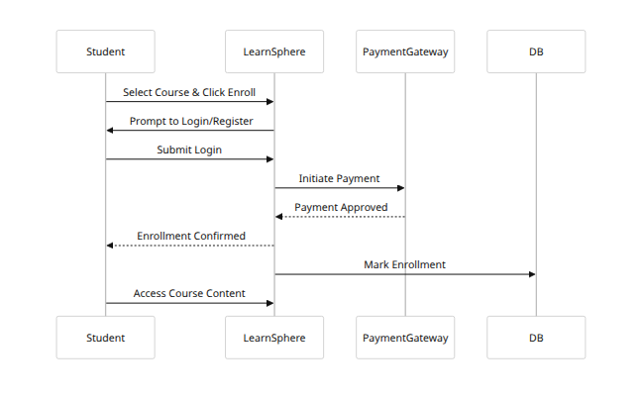
Figure G2. Sequence for course enrollment and payment processing.
Figure G3. High-Level Architecture: (Simplified component diagram)
graph LR
subgraph Frontend
UI[Web Browser (HTML/JS)]
end
subgraph Backend
APISrv[API Server (Django)]
AuthSrv[Auth Service]
CourseSrv[Course Service]
PaymentSrv[Payment Service]
DB[(Database)]
Storage[(Media Storage)]
end
UI --> APISrv
APISrv --> AuthSrv
APISrv --> CourseSrv
APISrv --> PaymentSrv
CourseSrv --> DB
AuthSrv --> DB
PaymentSrv --> DB
CourseSrv --> Storage
Figure G3. Component Diagram: Core server components (shown simply).
Figure G4. ER Diagram (Data Model):
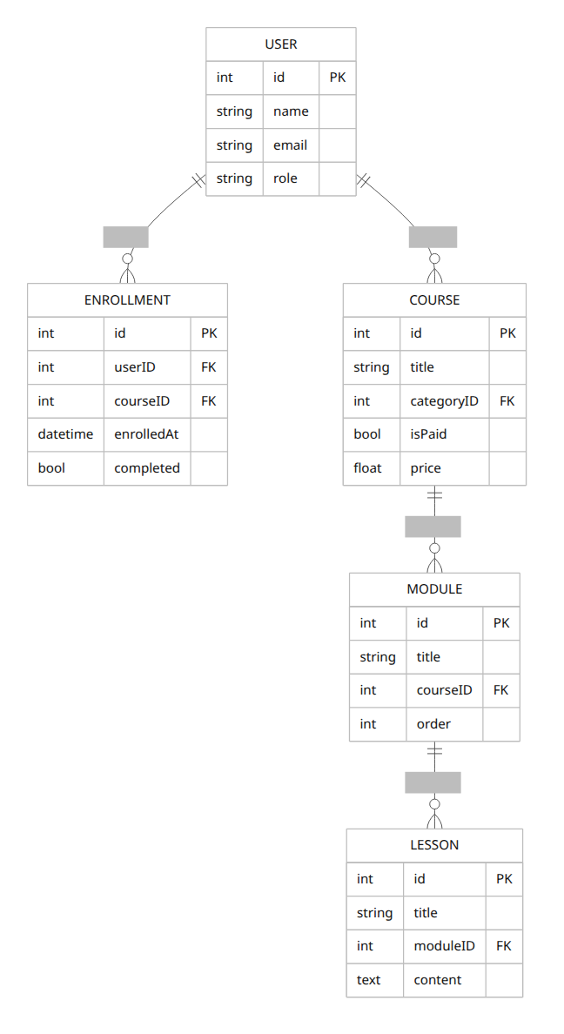
Figure G4. ER Diagram for core entities (Users, Courses, Modules, Lessons, Enrollments).

Appendix H: Schedule (Drafting Timeline)
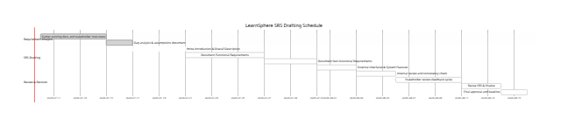
Figure H1. Gantt chart for the SRS development schedule (dates are illustrative).
Change History: Version 1.0 – Initial draft; subsequent versions will incorporate updates as requirements evolve.
Conclusion: This IEEE-format SRS comprehensively captures the LearnSphere platform requirements, with traceability and testability in mind. All stakeholder needs are addressed explicitly or via documented assumptions. The gaps identified are flagged for clarification. Nonfunctional metrics (e.g. performance targets) and compliance needs are clearly stated. This SRS serves as the authoritative basis for design, implementation, verification, and acceptance testing of LearnSphere.

